Lab Assignment 4
Name- Aye Myat Thiri Khin
ID-20293
Q : Design the following 2-bits RTL level combinational logic modules in continuous assignment and always blocks for each gate and write the testbench to verify your design covering all the testcases by showing the waveforms,

  - 1-bit NOT gate
  - 2-bits AND gate
  - 2-bits OR gate
  - 2-bits NAND gate
  - 2-bits NOR gate
  - 2-bits XOR gate
  - 2-bits XNOR gate

Ans:
(1)
- bit NOT gate
module not_gate (
input a,
output y
);
assign y = ~a;
endmodule
module test_not_gate;
reg a;
wire y;

not_gate uut (
.a(a),
.y(y)
);

initial begin
$dumpfile("not_gate.vcd"); // For VCD waveform generation
$dumpvars(0, test_not_gate);

// Test all input cases
a = 1'b0; #10;
a = 1'b1; #10;

$finish;
end
endmodule
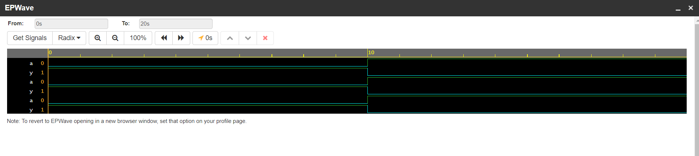

(2)
- bits AND gate
module and_gate_2bit (
input [1:0] a, b,
output [1:0] y
);
assign y = a & b;
endmodule
module test_and_gate_2bit;
reg [1:0] a, b;
wire [1:0] y;

and_gate_2bit uut (
.a(a),
.b(b),
.y(y)
);

initial begin
$dumpfile("and_gate_2bit.vcd");
$dumpvars(0, test_and_gate_2bit);

// Apply all input combinations
a = 2'b00; b = 2'b00; #10;
a = 2'b01; b = 2'b01; #10;
a = 2'b10; b = 2'b10; #10;
a = 2'b11; b = 2'b11; #10;

$finish;
end
endmodule
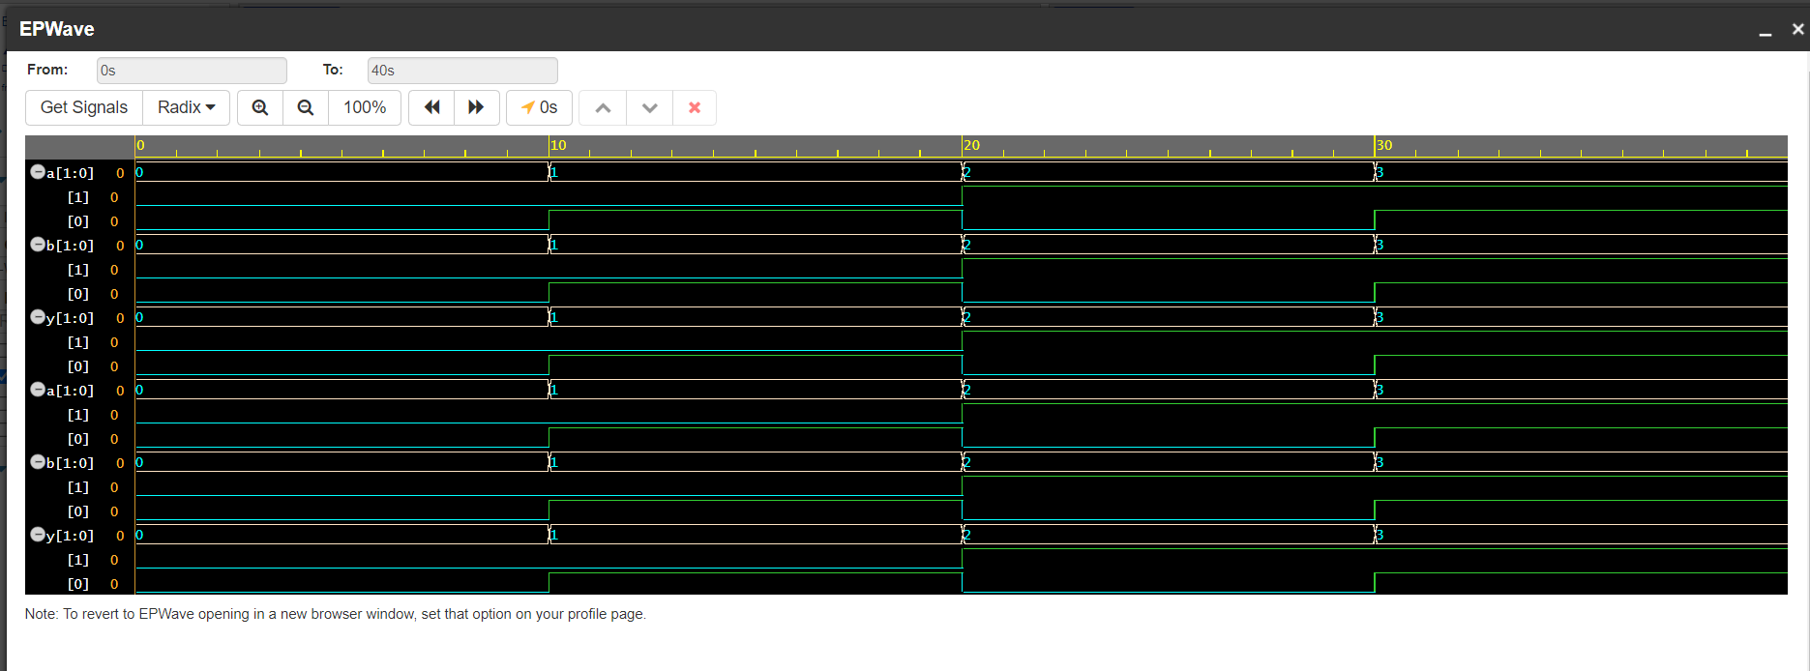
(3)
2-bits OR gate
module or_gate_2bit (
input [1:0] a, b,
output [1:0] y
);
assign y = a | b;
endmodule
module test_or_gate_2bit;
reg [1:0] a, b;
wire [1:0] y;

or_gate_2bit uut (
.a(a),
.b(b),
.y(y)
);

initial begin
$dumpfile("or_gate_2bit.vcd");
$dumpvars(0, test_or_gate_2bit);

// Test all cases
a = 2'b00; b = 2'b00; #10;
a = 2'b01; b = 2'b01; #10;
a = 2'b10; b = 2'b10; #10;
a = 2'b11; b = 2'b11; #10;

$finish;
end
endmodule
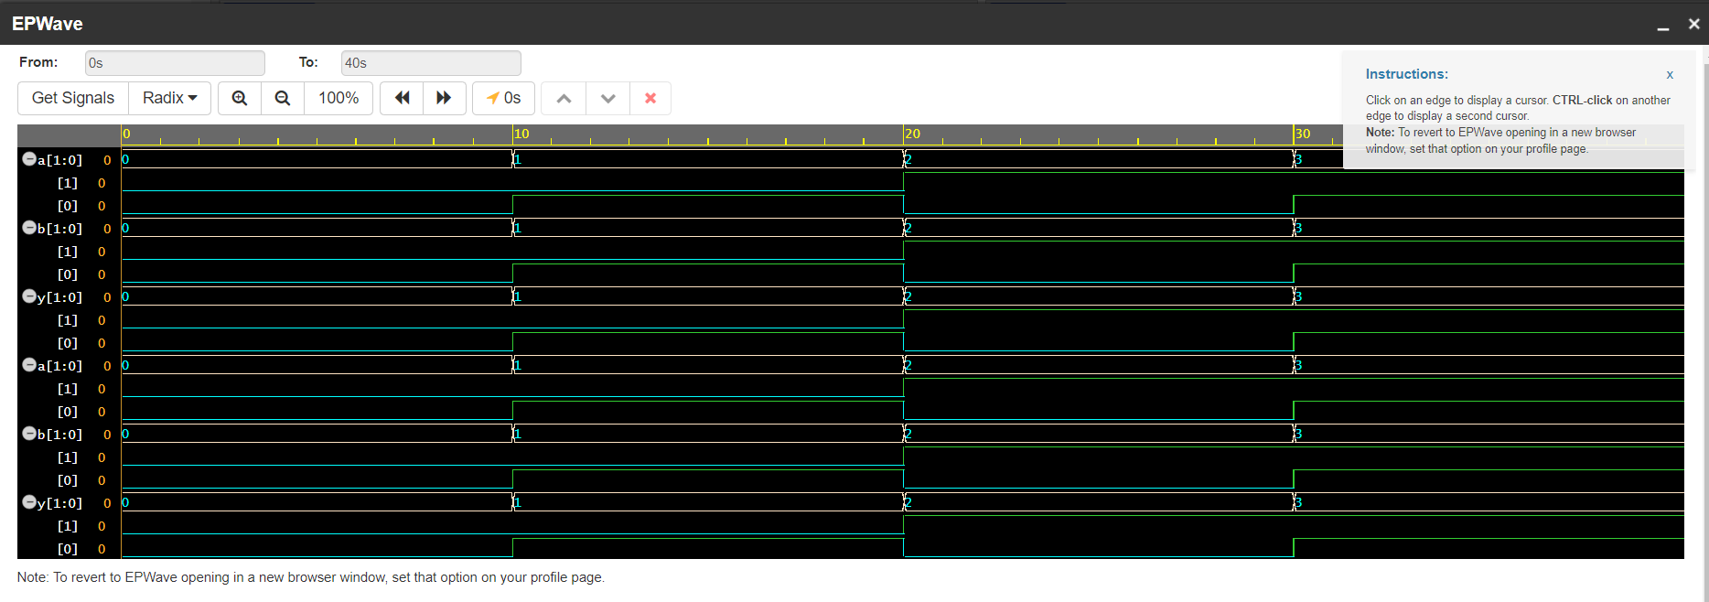
(4)
- bits NAND gate
module nand_gate_2bit (
input [1:0] a, b,
output [1:0] y
);
assign y = ~(a & b);
endmodule
module test_nand_gate_2bit;
reg [1:0] a, b;
wire [1:0] y;

nand_gate_2bit uut (
.a(a),
.b(b),
.y(y)
);

initial begin
$dumpfile("nand_gate_2bit.vcd");
$dumpvars(0, test_nand_gate_2bit);

// Test cases
a = 2'b00; b = 2'b00; #10;
a = 2'b01; b = 2'b01; #10;
a = 2'b10; b = 2'b10; #10;
a = 2'b11; b = 2'b11; #10;

$finish;
end
endmodule
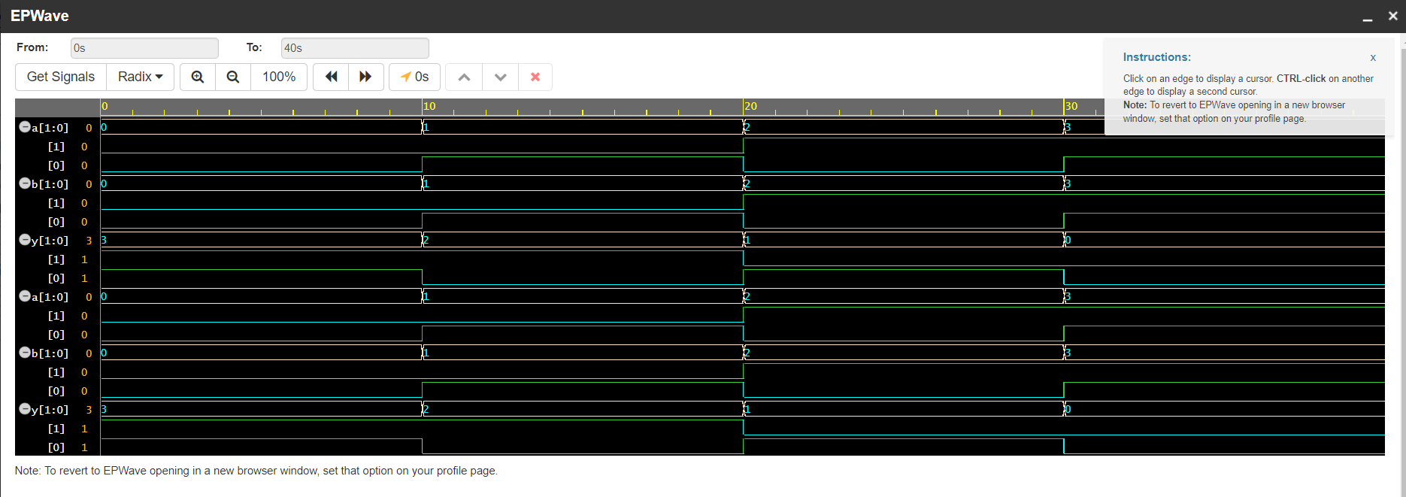
(5)
- bits NOR gate
module nor_gate_2bit (
input [1:0] a, b,
output [1:0] y
);
assign y = ~(a | b);
endmodule
module test_nor_gate_2bit;
reg [1:0] a, b;
wire [1:0] y;

// Instantiate the NOR gate module
nor_gate_2bit uut (
.a(a),
.b(b),
.y(y)
);

initial begin
$dumpfile("nor_gate_2bit.vcd"); // For VCD waveform generation
$dumpvars(0, test_nor_gate_2bit);

// Apply test cases
a = 2'b00; b = 2'b00; #10; // Expected output: y = 2'b11
a = 2'b01; b = 2'b00; #10; // Expected output: y = 2'b10
a = 2'b10; b = 2'b01; #10; // Expected output: y = 2'b00
a = 2'b11; b = 2'b11; #10; // Expected output: y = 2'b00

$finish;
end
endmodule
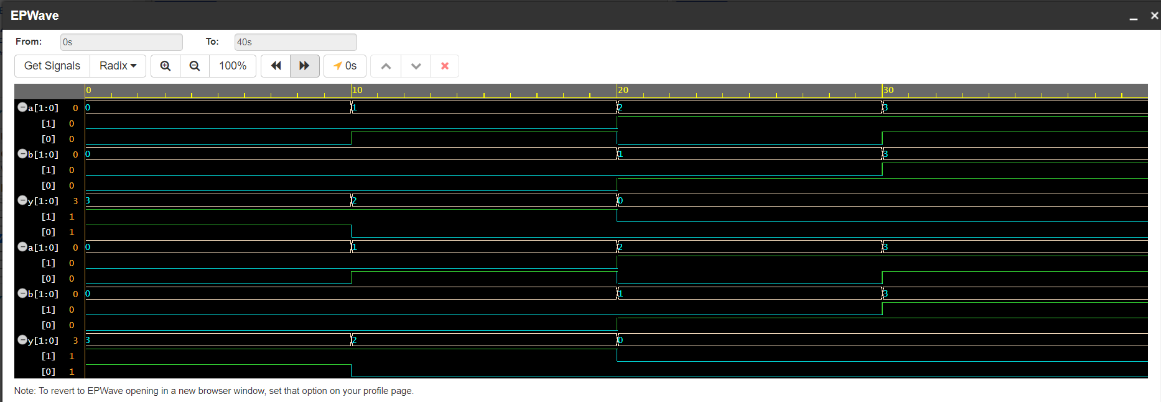
(6)
2-bits XOR gate
module xor_gate_2bit (
input [1:0] a, b,
output [1:0] y
);
assign y = a ^ b;
endmodule
module test_xor_gate_2bit;
reg [1:0] a, b;
wire [1:0] y;

// Instantiate the XOR gate module
xor_gate_2bit uut (
.a(a),
.b(b),
.y(y)
);

initial begin
$dumpfile("xor_gate_2bit.vcd"); // For VCD waveform generation
$dumpvars(0, test_xor_gate_2bit);

// Apply test cases
a = 2'b00; b = 2'b00; #10; // Expected output: y = 2'b00
a = 2'b01; b = 2'b01; #10; // Expected output: y = 2'b00
a = 2'b10; b = 2'b01; #10; // Expected output: y = 2'b11
a = 2'b11; b = 2'b10; #10; // Expected output: y = 2'b01

$finish;
end
endmodule
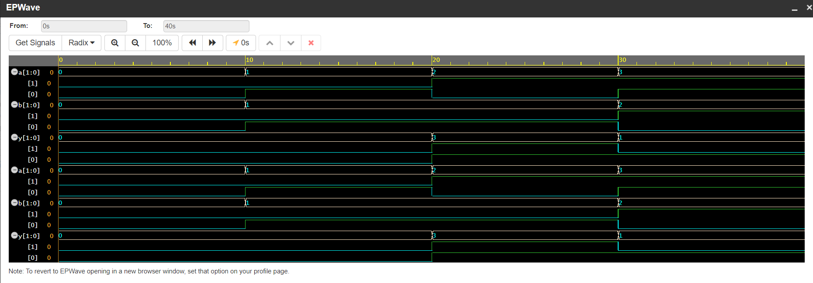
(7)
2-bits XNOR gate
module xnor_gate_2bit (
input [1:0] a, b,
output [1:0] y
);
assign y = ~(a ^ b);
endmodule
module test_xnor_gate_2bit;
reg [1:0] a, b;
wire [1:0] y;

// Instantiate the XNOR gate module
xnor_gate_2bit uut (
.a(a),
.b(b),
.y(y)
);

initial begin
$dumpfile("xnor_gate_2bit.vcd"); // For VCD waveform generation
$dumpvars(0, test_xnor_gate_2bit);

// Apply test cases
a = 2'b00; b = 2'b00; #10; // Expected output: y = 2'b11
a = 2'b01; b = 2'b01; #10; // Expected output: y = 2'b11
a = 2'b10; b = 2'b01; #10; // Expected output: y = 2'b00
a = 2'b11; b = 2'b10; #10; // Expected output: y = 2'b10

$finish;
end
endmodule
